[LSC logo]

Leicester Sketch Club
Winner of ‘Art Club of the Year 2016’ competition: The Artist & Leisure Painter
Programme 2018
www.leicestersketchclub.co.uk
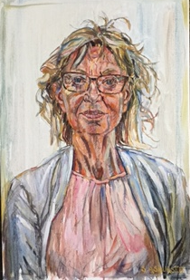
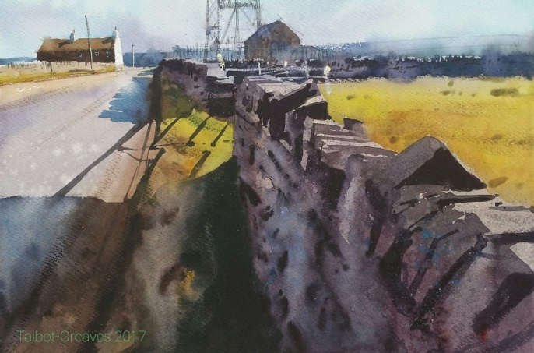
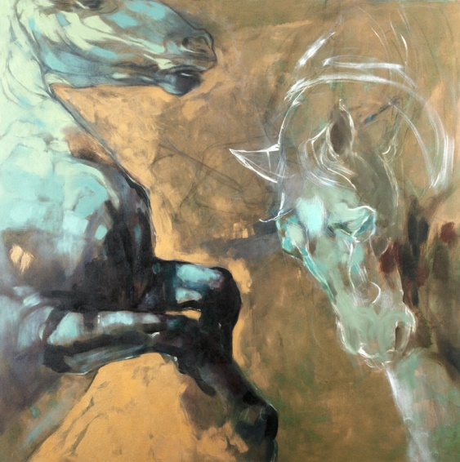

Monthly Meetings: Jan – Dec 2018
Meetings are held on the first Wednesday of the month at various locations and times. Non-members are welcome to meetings for £3 unless stated below.
* Booking required. More information can be found on the LSC website.
Jan 3 Sketch afternoon - practical session with a burlesque model (KPC)
1.30 – 3.30pm – LSC members only
Feb 7 * Pollyanna Pickering - a talk about her sketchbooks and trip to wildlife reserve
in China (LCB) 2.00 – 4.00pm – booking required via LSC, see website for details.
Non-members welcome. Reduced NCP car park fee available.
March 7 Mary Byrne – Critique (LHS) 7 – 9pm – LSC members only
April 4 Members demo day (LHS) 7 – 9pm – LSC members only
May 2 Gadsby’s demo and taster session (LHS) 7 – 9pm - non-members welcome
June 6 Louise Ellerington, artist and gallery owner – talk (LHS) 7 – 9pm - non-members welcome
July 4 Scott Bridgwood - Critique (LHS) 7 – 9pm – LSC members only
Aug 1 No meeting
Sept 5 Kevin Holdaway – talk about printmaking (LHS) 7 – 9pm - non-members welcome
Oct 3 Sketchbook night (LHS) 7 – 9pm – LSC members only
Nov 7 AGM and social evening (LHS) 7 – 9pm – LSC members only
Dec 5 Stephen Ashurst portrait demo (LHS) 7 – 9pm – LSC members only

Locations
(LHS) Leicester High School for Girls, 454 London Rd, LE2 2PP
(KPC) Knighton Parish Centre, Church Lane, Knighton, LE2 3WG
(LCB) LCB Depot Lightbox Gallery, 31 Rutland St, Leicester LE1 1RE

Annual Exhibition:
From date xx/xx/18 – To date xx/xx/18 (Launch date xx/xx/18)
The Old Library Café and Galleries
Leicester Adult Education College, 50-54 Belvoir St, Leicester LE1 6QL

Workshops: (Any available places will be offered to non-members one month beforehand for an extra £3 fee).
Sat 10th Feb – Life Drawing – A Different Approach – [tutor’s name?] 10am – 3.30pm (BVHC) £xx (16 places)
Sat 10th March – Collagraph Printing Workshop - Jo Sheppard – 10am – 3.30pm (BVHC) £28 (16 places)
Sat 14th April – Acrylic Painting – Paul Talbot Greaves - 10am – 3.30pm (BVHC) £39 (16 places)
Sat 29 Sept – Life Drawing _ Tony Sumptor – 1.30 – 4.30pm (KPC) £xx (17 places)
Sat 27 Oct – Life Drawing _ Tony Sumptor – 1.30 – 4.30pm (KPC) £xx (17 places)

Location:
(BVHC) Brocks Hill Visitor Centre, Washbrook Lane, Oadby, Leicester LE2 5JJ
(KPC) Knighton Parish Centre, Church Lane, Knighton, LE2 3WG

To book or check availability, see website or email enquiries@leicestersketchclub.co.uk

Indoor Sketching: (Members only).
Sat 24 March and Sat 28 April – portrait and still life – 1.30 – 4.30pm (KPC) - £10 for 2 afternoons
Sat 30 June and Sat 28 July – portrait and still life – 1.30 – 4.30pm (KPC) - £10 for 2 afternoons
Sat 29 Sept and Sat 27 Oct – portrait and still life – 1.30 – 4.30pm (KPC) - £10 for 2 afternoons

Location:
(KPC) Knighton Parish Centre, Church Lane, Knighton, LE2 3WG

To book or check availability, see website or email enquiries@leicestersketchclub.co.uk

Outdoor Sketching: Free. All welcome.

Sat 21st April - Abbey Park Café, Leicester – Spring colours - meet at the cafe 10am
Sat 26th May - Market Harborough Canal Basin – buildings and canal boats – meet by the Waterfront 10am.
Sat 14th July - Great Central Railway, Loughborough – listed buildings, people and stream trains - meet by the entrance 10am
Sat 8th Sept - Frog Island, Leicester - old factories, bridges and weir - meet on the Soar Lane bridge 10am

More locations and dates to follow! See the website for more details, and other events such as our Coffee and Sketch Mornings: www.leicestersketchclub.co.uk

About
The Leicester Sketch Club was founded in 1898 and has over 120 members ranging from recognised experienced artists to developing part time artists. It aims to encourage the artistic development of each. The yearly programme includes: monthly meetings with talks, demonstrations and critiques; it has an annual exhibition, workshops, group indoor and outdoor sketching sessions, plus several social opportunities throughout the year. Non members are very welcome to attend many of our events – some include a £3 fee and some are free. See website www.leicestersketchclub.co.uk for more details, or email: enquiries@leicestersketchclub.co.uk

[facebook logo] LeicesterSketchClub [twitterlogo] LeicSketchClub [Instagram logo] leicsketchclub

Membership Deadlines for application: 5th Jan 2018 and 22nd June 2018
Annual Full Membership Fee: £30
Membership includes the opportunity to exhibit in the Annual Exhibition, a page on the LSC website, newsletter and free access to all monthly meetings. Online applications will be reviewed by a selection Committee. There is a £3 admin fee for all new full members. Annual membership fee for successful June applications reduced to £15.
Annual Associate Membership Fee: £20
Applicants may join without going through the review process of showing work but cannot enter the Club’s exhibitions or Critiques. Free access to all meetings. There is a £3 admin fee for all new Associate members. Annual membership fee for successful June applications reduced to £10.
Annual Student Membership Fee: £15
Must hold a student identity card. The same rules apply as an Associate Member. Annual membership fee for successful June applications reduced to £7.50.

Front cover shows work from invited guest artist appearing on our programme. Left column: artist name ‘title’, artist name ‘title’; Right column: artist name ‘title’, artist name ‘title’. [artwork to be agreed with guests]

