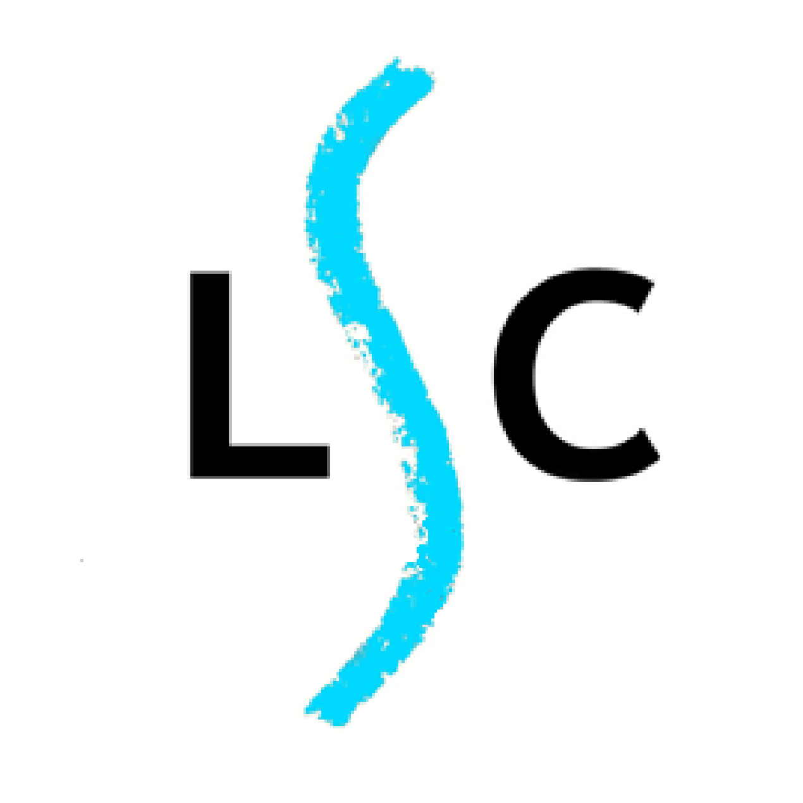
LOCATION: LASALS,
LEICESTER SKETCH CLUB
ANNUAL EXHIBITION 2018
APPLICATION FORM FOR MEMBERS
The Old Library Café & Galleries, Leicester Adult Education College, 50-54 Belvoir Street, Leicester, LE1 6QL
EXHIBITION DATES: Friday October 19th to Wednesday Nov 28th 2018 (Exhibition closes 1pm)
LAUNCH: 6pm – 8.30pm Thursday October 18th - All Welcome
OPENING TIMES: Monday to Thursday 8.30 - 9.00, Fridays 8.30 - 4.30, Saturday 8.45 - 4.30
(During half term 22nd October, Exhibition may close earlier 6.30pm)
SUBMISSION OF ENTRIES
BRYAN WARD PRIZE
Please tick box if eligible
for the Bryan Ward Prize
(See conditions for Prize.)

Closing date for entries: Friday 21st September
Handing in of works: Tuesday 16th October 3 – 5pm
Collection of works: Wednesday Nov 28th from 2 – 3.30pm

I wish to submit the following work for review by the committee and agree to abide by the conditions as detailed overleaf

NAME
(Please print your name as you wish it to appear in the catalogue)

ADDRESS

POSTCODE TEL.

Please note, space is always at a premium at the exhibition and while the committee will endeavour to include all eligible entries, there is no guarantee that all works submitted will be exhibited. Please indicate your preference for exhibiting in the order you enter your works below. Diptychs/Triptychs must be in one frame or hinged as one work and below the 110 x 110 cm.
Title of first work (Please keep under 3 words)  Maximum size 110 x 110 cm framed. | Medium | Price or NFS | Date Created
Height x Width | Official use - in |  | Collected
Title of second work (Please keep under 3 words)  Maximum size 65 x 70 cms framed. | Medium | Price or NFS | Date Created
Height x Width | Official use - in |  | Collected
Title of third work (Please keep under 3 words)  Maximum size 65 x 70 cms framed. | Medium | Price or NFS | Date Created
Height x Width | Official use - in |  | Collected
Entry Fee: £15 for one work or £25 for up to three works.
Please remember to add 10% commission if selling your work.
Fee Payable Please tick if paid by BACS
Please post this form to: C. Mannion, 1, Heron Way, Enderby, Leic. LE19 2AJ. with a cheque for the fee, payable to ‘Leicester Sketch Club’ or pay by BACS: NatWest Bank account no 89911016, sort code 60-14-19. Your form can be emailed to artbychristine@btinternet.com
Please ensure you identify your payment with EX(+ your family name)

