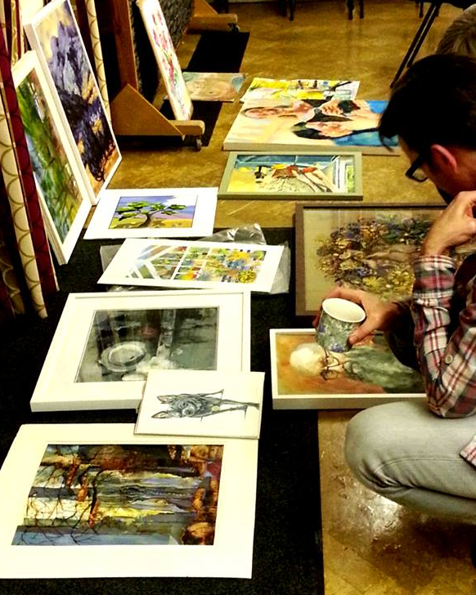
Date Saturday April 27th, 2 – 4pm (please arrive 20 minutes early to allow work to be sorted before the start of the session)
Venue Knighton Parish Centre
Tutor Diane Hall
Cost £12
10 places

We are excited to be introducing a new style of critique in the New Year, which we are hoping will help with artistic development of members at all levels, including associates.
The groups will be small (up to 10 members) which will allow more in-depth analysis and discussion of members’ work-in-progress. There will be an opportunity to get feedback from the group in a supportive environment. You will also be able to see other people’s work, and to understand the critique process (which is not so much about whether we like a piece of artwork but whether it works in terms of the different formal elements). The group will discuss how work could be developed.
The tutor for this session will be Diane Hall and the cost is £12 for the session.
You can bring up to 3 pieces of work, plus supporting sketches.
To book a place, send an email to enquiries@leicestersketchclub.co.uk or book at the monthly meetings.

