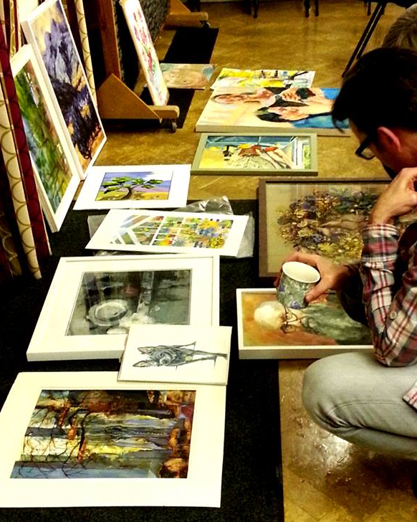
Date Saturday January 26th, 2 – 4pm (please arrive 20 minutes early to allow work to be sorted before the start of the session)
Venue Knighton Parish Centre
Tutor Jacqui Gallon
Cost £12
10 places

We are excited to be introducing a new style of critique in the New Year, which we are hoping will help with artistic development of members at all levels, including associates.
The groups will be small (up to 10 members) which will allow more in-depth analysis and discussion of members’ work-in-progress. There will be an opportunity to get feedback from the group in a supportive environment. You will also be able to see other people’s work, and to understand the critique process (which is not so much about whether we like a piece of artwork but whether it works in terms of the different formal elements). The group will discuss how work could be developed.
We are now taking bookings for the first session on Saturday January 26th, 2 – 4pm, at Knighton Parish Centre. The tutor will be Jacqui Gallon and the cost is £12 for the session. Jacqui is an experienced teacher, with qualifications in both fine art practice and art history.
You can bring up to 3 pieces of work, plus supporting sketches.
Additionally if you would like to send images of your work beforehand, Jacqui will prepare useful and relevant artist references to help with your development.
To book a place, send an email to enquiries@leicestersketchclub.co.uk , or book at the monthly meeting.

